Week 4 homework

Instructions
Part 1. Draw the line y=4x+3 on a plot that ranges from -20 to +20 on both x and y. Label the line appropriately next to itself. Color the line in an interesting color! And make it dashed. Bonus Use a combination of the above options (plus others, if you feel like looking them up) to create the wildest looking series of lines on a graph that you can. (Remember, you can overplot lines!)

Part 1.
graphics.off()
plot(x=0,type='n',xlim=c(-20,20), ylim=c(-20,20),xlab = "X",ylab="Y",main = "Drawing an IMPORTANT line ")
abline(a=3,
b=4,
col="seagreen3",
lwd=3,
lty="dashed")
text(5,8,"y=4x+3",col = "black")
Part 2. Protected Lands Consider the protected_lands.csv dataset. This dataset contains information about a sample of countries sourced from the World Bank. Protected Lands represents the terrestrial protected land of a country as a percentage of total land area. GDP is represented in the dataset on a per capita (gdp_percap) as well as total basis (with total being measured in billions - tot_gdp_billions).
Find the mean, standard deviation, and range of each of the three variables: protected lands, GDP per capita, and total GDP.
Create a scatterplot where “protected lands” is on the Y axis and GDP per capita is on the X axis. Place a title on the graph and labels on the X and Y axis appropriately.
Create a scatterplot where “protected lands” is on the Y axis and total GDP is on the X axis. Place a title on the graph and labels on the X and Y axis appropriately.
Regress “protected lands” on GDP per capita.
Create a scatterplot where “protected lands” is on the Y axis and GDP per capita is on the X axis. Then, overlay the plot with a best fit line.
Regress “protected land” on total GDP.
Create a scatterplot where “protected lands” is on the Y axis and total GDP is on the X axis. Then, overlay the plot with a best fit line.

Part 2.
#1
graphics.off()
df <- data <- read.csv("~/Downloads/PAI 741/Data Sets/protected_lands.csv")
#mean, standard deviation, and range
mean(df$protected_lands)
[1] 18.38462
sd(df$protected_lands)
[1] 10.89754
range(df$protected_lands)
[1] 4 42
mean(df$gdp_percap)
[1] 25210.38
sd(df$gdp_percap)
[1] 19337.7
range(df$gdp_percap)
[1] 3156 58553
mean(df$tot_gdp_bilions)
[1] 1125.923
sd(df$tot_gdp_bilions)
[1] 3056.297
range(df$tot_gdp_bilions)
[1] 20 11199
# 2
plot(df$gdp_percap, df$protected_lands,
main = "Protected Lands vs GDP per Capita",
xlab = "GDP per Capita",
ylab = "Protected Lands (%)")
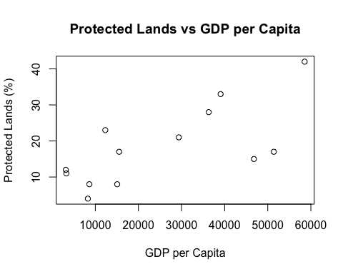
# 3
plot(df$tot_gdp_bilions, df$protected_lands,
main = "Protected Lands vs Total GDP",
xlab = "Total GDP (Billions)",
ylab = "Protected Lands (%)")
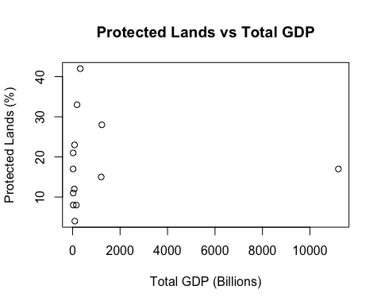
# 4
model1 <- lm(protected_lands ~ gdp_percap, data = df)
summary(model1)
Call:
lm(formula = protected_lands ~ gdp_percap, data = df)
Residuals:
Min 1Q Median 3Q Max
-11.925 -6.373 1.292 5.223 10.420
Coefficients:
Estimate Std. Error t value Pr(>|t|)
(Intercept) 8.4075115 3.7882055 2.219 0.04842 *
gdp_percap 0.0003958 0.0001210 3.272 0.00744 **
---
Signif. codes: 0 '***' 0.001 '**' 0.01 '*' 0.05 '.' 0.1 ' ' 1
Residual standard error: 8.103 on 11 degrees of freedom
Multiple R-squared: 0.4932, Adjusted R-squared: 0.4471
F-statistic: 10.7 on 1 and 11 DF, p-value: 0.007443
#5
plot(df$gdp_percap, df$protected_lands,
main = "Protected Lands vs GDP per Capita",
xlab = "GDP per Capita",
ylab = "Protected Lands (%)")
abline(model1)
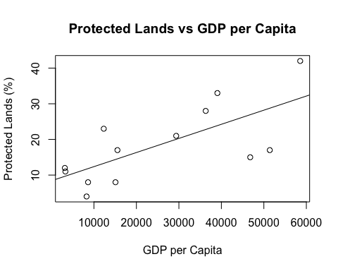
# 6
model2 <- lm(protected_lands ~ tot_gdp_bilions, data = df)
summary(model2)
Call:
lm(formula = protected_lands ~ tot_gdp_bilions, data = df)
Residuals:
Min 1Q Median 3Q Max
-14.393 -7.394 -1.394 4.607 23.609
Coefficients:
Estimate Std. Error t value Pr(>|t|)
(Intercept) 1.839e+01 3.381e+00 5.440 0.000204 ***
tot_gdp_bilions -8.177e-06 1.075e-03 -0.008 0.994067
---
Signif. codes: 0 '***' 0.001 '**' 0.01 '*' 0.05 '.' 0.1 ' ' 1
Residual standard error: 11.38 on 11 degrees of freedom
Multiple R-squared: 5.26e-06, Adjusted R-squared: -0.0909
F-statistic: 5.786e-05 on 1 and 11 DF, p-value: 0.9941
# 7
plot(df$tot_gdp_bilions, df$protected_lands,
main = "Protected Lands vs Total GDP",
xlab = "Total GDP (Billions)", ylab = "Protected Lands (%)")
abline(model2)


